* CREDIT CARD SPENDING HABITS IN INDIA SQL QUERY REPORT
* FIRST & LAST TRANSACTION DETAILS :
  + SELECT MIN(date) as first_transaction_date, MAX(date) AS last_transaction_date
  + FROM cc_transactions.cc;
  + 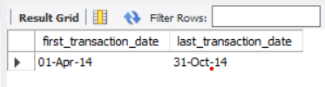
* DIFFERENT TYPE OF CARDS :
  + SELECT DISTINCT card_type
  + FROM cc_transactions.cc;
  + 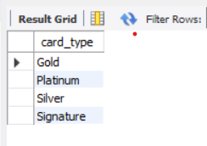
* EXPENSES WHERE USERS SPEND THEIR MONEY :
  + SELECT DISTINCT exp_type
  + FROM cc_transactions.cc;
  + 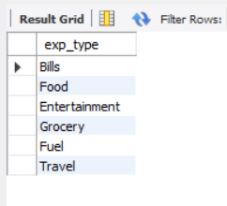
* TOP 5 CITIES WITH HIGHEST SPENDS :
  + WITH top_5_pct as
  + (SELECT DISTINCT city,
  + SUM(amount)OVER() AS total_spends_by_all_city,
  + SUM(amount) OVER(PARTITION BY city) AS total_spends_per_city
  + FROM cc_transactions.cc
  + )
  + SELECT * FROM (
  + SELECT city,
  + ROUND(total_spends_per_city/total_spends_by_all_city * 100,2) AS pct_count,
  + DENSE_RANK() OVER(ORDER BY total_spends_per_city DESC)AS ranker
  + FROM top_5_pct) x
  + WHERE ranker <=5;
  + 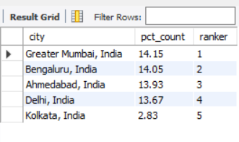
* WHEN DOES A CARD REACHES TO A CUMMULATIVE SPENDS OF 10,00,000 INR
  + WITH first_reach as
  + (SELECT * ,
  + SUM(amount) OVER(PARTITION BY card_type ORDER BY date,ind) AS cummulative_sum
  + FROM cc_transactions.cc)
  + SELECT * FROM
  + (SELECT * ,
  + RANK() OVER(PARTITION BY card_type ORDER BY cummulative_sum) AS ranker
  + FROM first_reach
  + WHERE cummulative_sum >= 1000000
  + ) x
  + WHERE x.ranker = 1;
  + 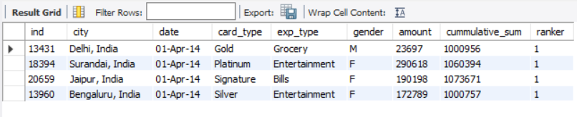
* CITY WHICH HAD LOWEST PERCENTAGE SPEND FOR GOLD TYPE :
  + WITH gold_spends_pct as
  + (SELECT city,card_type, sum(amount) AS total_spends,
  + SUM(CASE WHEN card_type = 'Gold' THEN amount end) AS gold_amount
  + FROM cc_transactions.cc
  + GROUP BY city,card_type)
  + SELECT city, SUM(gold_amount)*1.0 / SUM(total_spends) AS total_amount
  + FROM gold_spends_pct
  + GROUP BY city
  + HAVING COUNT(gold_amount) > 0
  + ORDER BY total_amount
  + LIMIT 1;
  + 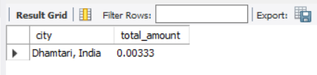
* DIFFERENT CITIES AND THEIR HIGHEST SPENDS EXPENSE TYPE AND LOWEST SPENDS EXPENSE TYPE :
  + WITH high_low as
  + (SELECT city,exp_type, SUM(amount) AS total_amount,
  + DENSE_RANK() OVER(PARTITION BY city ORDER BY sum(amount) DESC) as dsc_rnk,
  + FROM cc_transactions.cc
  + GROUP BY city,exp_type
  + ORDER BY city,exp_type)
  + SELECT city, MAX(CASE WHEN dsc_rnk = 1 then exp_type end) as high_exp,
  + MAX(CASE WHEN asc_rnk = 1 then exp_type end) as low_exp
  + FROM high_low
  + GROUP BY city
  + 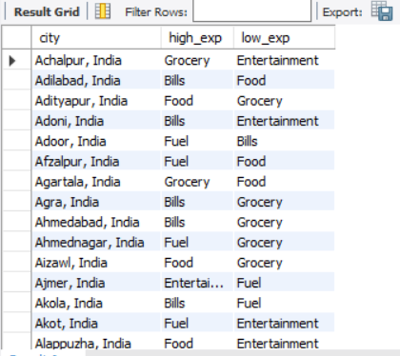
* PERCENTAGE CONTRIBUTION OF FEMALES FOR EACH EXPENSE TYPE:
  + SELECT exp_type, ROUND(100* SUM(CASE WHEN Gender = 'F' then amount else 0 end) / SUM(amount),2) as pct
  + FROM cc_transactions.cc
  + GROUP BY exp_type
  + ORDER BY pct DESC;
  + 